**Unit 4**

**1)Introduction to Input-Output interface**

[Input-Output Interface](https://www.geeksforgeeks.org/structure-of-input-output-interface/) is used as an method which helps in transferring of information between the internal storage devices i.e. memory and the external peripheral device . A peripheral device is that which provide input and output for the computer, it is also called Input-Output devices. For Example: A keyboard and mouse provide Input to the computer are called input devices while a monitor and printer that provide output to the computer are called output devices. Just like the external hard-drives, there is also availability of some peripheral devices which are able to provide both input and output.

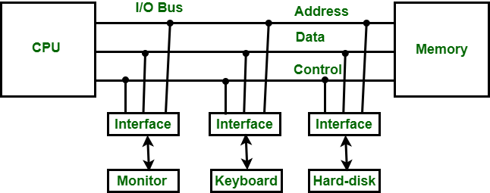

Input-Output Interface

In micro-computer base system, the only purpose of peripheral devices is just to provide special communication links for the interfacing them with the CPU. To resolve the differences between peripheral devices and CPU, there is a special need for communication links.

The major differences are as follows:

1. The nature of peripheral devices is electromagnetic and electro-mechanical. The nature of the CPU is electronic. There is a lot of difference in the mode of operation of both peripheral devices and CPU.
2. There is also a synchronization mechanism because the data transfer rate of peripheral devices are slow than CPU.
3. In peripheral devices, data code and formats are differ from the format in the CPU and memory.
4. The operating mode of peripheral devices are different and each may be controlled so as not to disturb the operation of other peripheral devices connected to CPU.

There is a special need of the additional hardware to resolve the differences between CPU and peripheral devices to supervise and synchronize all input and output devices.

### Functions of Input-Output Interface:

1. It is used to synchronize the operating speed of CPU with respect to input-output devices.
2. It selects the input-output device which is appropriate for the interpretation of the input-output device.
3. It is capable of providing signals like control and timing signals.
4. In this data buffering can be possible through data bus.
5. There are various error detectors.
6. It converts serial data into parallel data and vice-versa.
7. It also convert digital data into analog signal and vice-versa.

2)Explain Programmed IO

Programmed I/O: It is due to the result of the I/O instructions that are written in the computer program. Each data item transfer is initiated by an instruction in the program. Usually the transfer is from a CPU register and memory. In this case it requires constant monitoring by the CPU of the peripheral devices.

Example of Programmed I/O: In this case, the I/O device does not have direct access to the memory unit. A transfer from I/O device to memory requires the execution of several instructions by the CPU, including an input instruction to transfer the data from device to the CPU and store instruction to transfer the data from CPU to memory. In programmed I/O, the CPU stays in the program loop until the I/O unit indicates that it is ready for data transfer. This is a time consuming process since it needlessly keeps the CPU busy. This situation can be avoided by using an interrupt facility. This is discussed below.

3)Explain DMA

Direct Memory Access: The data transfer between a fast storage media such as magnetic disk and memory unit is limited by the speed of the CPU. Thus we can allow the peripherals directly communicate with each other using the memory buses, removing the intervention of the CPU. This type of data transfer technique is known as DMA or direct memory access. During DMA the CPU is idle and it has no control over the memory buses. The DMA controller takes over the buses to manage the transfer directly between the I/O devices and the memory unit.

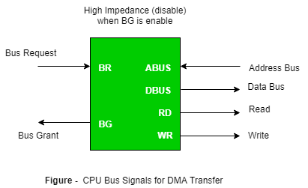

Bus Request : It is used by the DMA controller to request the CPU to relinquish the control of the buses.

Bus Grant : It is activated by the CPU to Inform the external DMA controller that the buses are in high impedance state and the requesting DMA can take control of the buses. Once the DMA has taken the control of the buses it transfers the data. This transfer can take place in many ways.

4)Explain PCI

PCI slots are utilized to install sound cards, Ethernet and remote cards and presently strong state drives utilizing NVMe innovation to supply SSD drive speeds that are numerous times speedier than SATA SSD speeds. PCI openings too permit discrete design cards to be included to a computer as well.

PCI openings (and their variations) permit you to include expansion cards to a motherboard. The extension cards increment the machines capabilities past what the motherboard may create alone, such as: upgraded illustrations, extended sound, expanded USB and difficult drive controller, and extra arrange interface options, to title a couple of.

Advantage of PCI :

* You’ll interface a greatest of five components to the PCI and you’ll be able moreover supplant each of them by settled gadgets on the motherboard.
* You have different PCI buses on the same computer.
* The PCI transport will improve the speed of the exchanges from 33MHz to 133 MHz with a transfer rate of 1 gigabyte per second.
* The PCI can handle gadgets employing a greatest of 5 volts and the pins utilized can exchange more that one flag through one stick.

Disadvantage of PCI :

* PCI Graphics Card cannot get to to system memory.
* PCI does not support pipeline.

Attention reader! Don’t stop learning now. Get hold of all the important CS Theory concepts for SDE interviews with the [CS Theory Course](https://practice.geeksforgeeks.org/courses/SDE-theory?vC=1) at a student-friendly price and become industry ready.

5)What is Small Computer System Interface?

A small computer systems interface (SCSI) is a standard interface for connecting peripheral devices to a PC. Depending on the standard, generally it can connect up to 16 peripheral devices using a single bus including one host adapter. SCSI is used to increase performance, deliver faster data transfer transmission and provide larger expansion for devices such as CD-ROM drives, scanners, DVD drives and CD writers. SCSI is also frequently used with RAID, servers, high-performance PCs and storage area networks SCSI has a controller in charge of transferring data between the devices and the SCSI bus. It is either embedded on the motherboard or a host adapter is inserted into an expansion slot on the motherboard. The controller also contains SCSI basic input/output system, which is a small chip providing the required software to access and control devices. Each device on a parallel SCSI bus must be assigned a number between 0 and 7 on a narrow bus or 0 and 15 on a wider bus. This number is called an SCSI ID. Newer serial SCSI IDs such as serialattached SCSI (SAS) use an automatic process assigning a 7-bit number with the use of serial storage architecture initiators.

6)What is USB?

USB was designed to standardize the connection of peripherals like pointing devices, keyboards, digital still and video cameras. But soon devices such as printers, portable media players, disk drives and network adaptors to personal computers used USB to communicate and to supply electric power. It is a commonplace to many devices and has largely replaced interfaces such as serial ports and parallel ports. USB connectors have replaced other types for battery chargers of portable devices with itself.

Advantages of USB –

The Universal Serial Bus was designed to simplify and improve the interface between personal computers and peripheral devices, when compared with previously existing standard or ad-hoc proprietary interfaces.

1. The USB interface is self-configuring. This means that the user need not adjust settings on the device and interface for speed or data format, or configure interrupts, input/output addresses, or direct memory access channels.
2. USB connectors are standardized at the host, so any peripheral can use any available receptacle. USB takes full advantage of the additional processing power that can be economically put into peripheral devices so that they can manage themselves. USB devices mostly do not have user-adjustable interface settings.
3. The USB interface is hot pluggable or plug and play, meaning devices can be exchanged without rebooting the host computer. Small devices can be powered directly from the USB interface thus removing extra power supply cables.
4. The USB interface defines protocols for improving reliability over previous interfaces and recovery from common errors.
5. Installation of a device relying on the USB standard minimal operator action is required.

Disadvantages of USB –

1. USB cables are limited in length.
2. USB has a strict “tree” topology and “master-slave” protocol for addressing peripheral devices. Peripheral devices cannot interact with one another except via the host, and two hosts cannot communicate over their USB ports directly.
3. Some very high speed peripheral devices require sustained speeds not available in the USB standard.
4. For a product developer, use of USB requires implementation of a complex protocol and implies an intelligent controller in the peripheral device.
5. Use of the USB logos on the product require annual fees and membership in the organization.